Interesting fact: My father Elmo Tull’s ______ cousin/uncle through his grandmother’s Mathis/Knight line Charner Hopson Knight was possibly cared for by my husband’s Bowdoin great grandfather Josephus Daniel Bowdoin (Pharmacist Kingston Hospital, 66th GA Regiment Confederate Army) & great uncle John W. Bowdoin MD, assistant surgeon at Kingston hospital in the Cassville area. Family tree information in Ancestery.com says that Charner Hopson Knight died in Cassville, Bartow, GA 6 Nov 1863 and records from “C.S. Army Deaths at Cassville, Georgia Hospitals” show a C.H. Knight, Company B, 32nd Mississippi, died Oct 22, 1863.
BARTOW COUNTY, GA - MILITARY Cassville Hospital CSA

*****************
Copyright. All rights reserved.
http://www.usgwarchives.net/copyright.htm

http://files.usgwarchives.net/ga/bartow/military/civilwar/cassville.txt
“ The following list of names, originally arranged by
state, but re-arranged alphabetically by this author,
was extracted from the Atlanta newspaper, the Southern
Confederacy, dated March 25, 1864, and was preceded by
the following notation:

"Below is appended a list of all deaths occurring among
the soldiers at this post in the Newsom, Frank Ramsay,
University and Flewellan Hospitals, from the 12th of
October, 1863, to March 16th, 1864. By giving this
list publicity some bereaved family may possibly
receive the first tidings that a loved member of the
home circle has gone to his last sleep, and to them is
given the consolation that nothing was left undone by
experienced and humane and attentive physicians to
arrest the destroyer."

Each name is followed by the soldiers unit, and then
the date of death. All the deaths shown occurred in
the five or six month period prior to the publication
of the list of names, and is not a complete listing of
all deaths at the Cassville hospitals throughout the
war.” [A full extract & listing of all deaths is at the end of this story.

C.H. Knight, company B, 32nd Mississippi, October 22,
1863.

The Bowdoin’s had settled in the Adairsville area of Bartow County in 1830s. As a member of the Mississippi Milita, it is unknown how Charner Knight got to Cassville or the circumstances of his death. He may have been buried in the Confederate cemetery. Looking at the map, it probably took months for confederate forces to go from Mississippi to the Battles of Chattanooga. The 2nd Battle of Chattanooga was August 21 1863 & primarily an artillery battle so perhaps Charner was wounded & evacuated to a hospital in Cassville south of the battle.

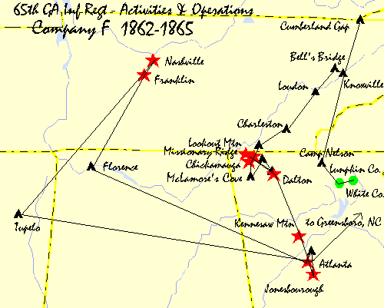

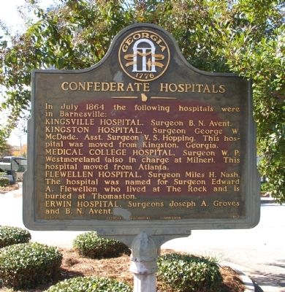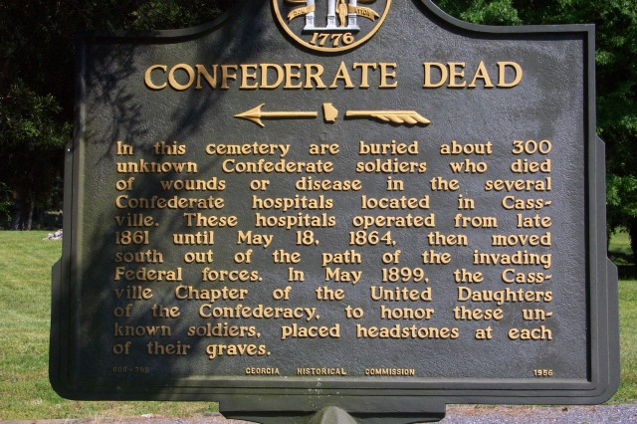

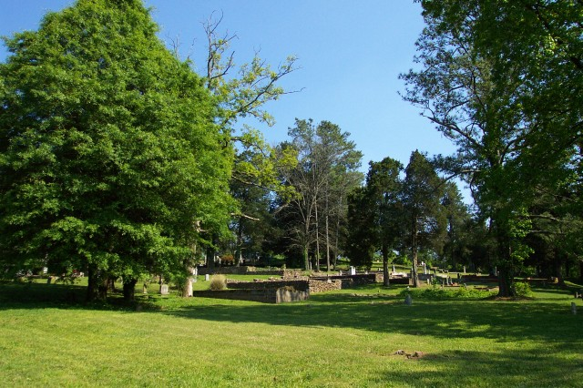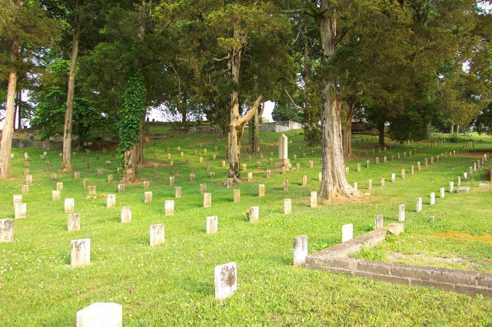

Perhaps he was a member of the Turner’s Mississippi Light Artillery Battery which mustered in the Kingston- Cass area.
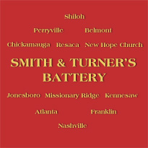 According to the following, the flag in question may have looked something like this. The banner was probably made after the war for the unit's original battery commander.
Confederate Veteran
(Vol II 1894, p.335)
J. E. LaBesse, Lake Charles, La., makes inquiry of any members of the Smith & Turner Battery, of Quitman, Miss., and adds: “I have in my possession an old flag which bears on one side the words, ‘Smith & Turner’s Battery,’ with the following battles surrounding it: Shiloh, Perryville, Belmont, Chickamauga, Resaca, New Hope Church, Jonesboro, Missionary Ridge, Kennesaw, Atlanta, Franklin, and Nashville. On the reverse is the Goddess of Liberty, with the following: ‘Our Liberty. Ready to die in its defense.’ I am desirous of corresponding with some of its members in order to ascertain the origin, etc., of this priceless relic. My wife’s father, who commanded this battery, was Col. Melanchthon Smith, now deceased.”

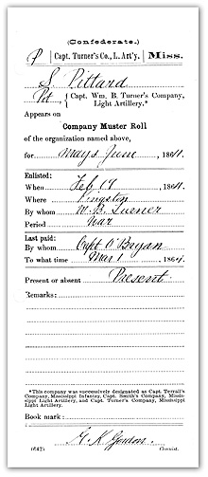

This area was in the path of federal forces moving from Chattanooga to Atlanta and afterwards led to Sherman moving across the south with 62,000 men in his “March to the Sea”. Cassville was burned by Sherman in 1864 & never rebuilt. More about the ivil war battles around Cassville can be found at http://www.cassvillehistoricalsociety.com/history/

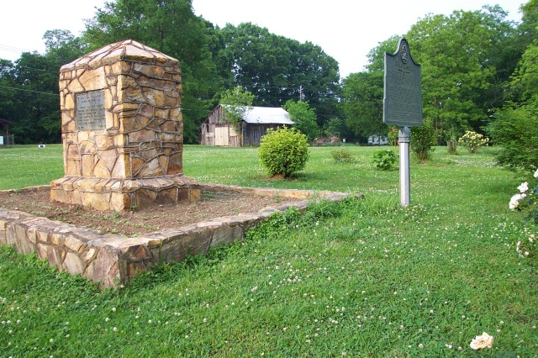

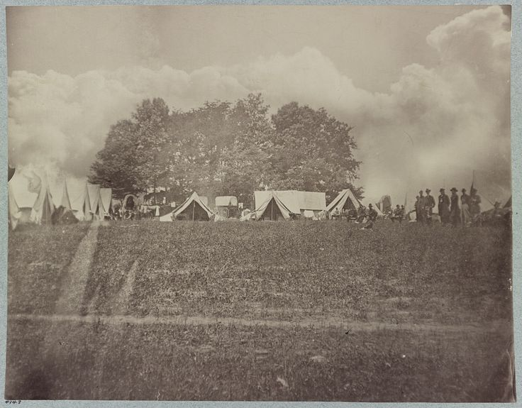 Headquarters of Gen. Geo. H. Thomas, near Cassville, Ga., May 21, 1864

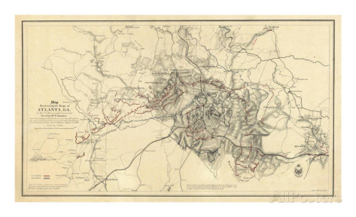

Adairsville
Civil War Georgia

http://americancivilwar.com/statepic/ga/ga009.html
Following the Battle of Resaca, May 13-15, General Joseph E. Johnston' s army retreated southward while Sherman pursued.
Failing to find a good defensive position south of Calhoun, Johnston continued to Adairsville while the Rebel cavalry fought a skillful rearguard action.
On the 17th, skirmish fire continued throughout the day and into the early evening. Major General O.O. Howard's IV Corps ran into entrenched infantry of Lieutenant General William J. Hardee' s corps, while advancing, about two miles north of Adairsville.
The 44th Illinois and 24th Wisconsin (under the command of Major Arthur MacArthur, father of Douglas) attacked Cheatham's Division at Robert Saxon (the Octagon House) and incurred heavy losses.
Three Union divisions prepared for battle, but Major General George H. Thomas halted them due to the approach of darkness. Sherman then concentrated his men in the Adairsville area to attack Johnston the next day.
Johnston had originally expected to find a valley at Adairsville of suitable width to deploy his men and anchor his line with the flanks on hills. The valley, however, was too wide, so Johnston disengaged and withdrew.
Result(s): Confederate delaying action (Allowed Johnston to bait a trap at Cassville.)

Further information about this area & era extracted from: FOUR HOSPITALS IN TINY CASSVILLE? http://www.gabartow.org/Military/civilWar/hospitals.shtml

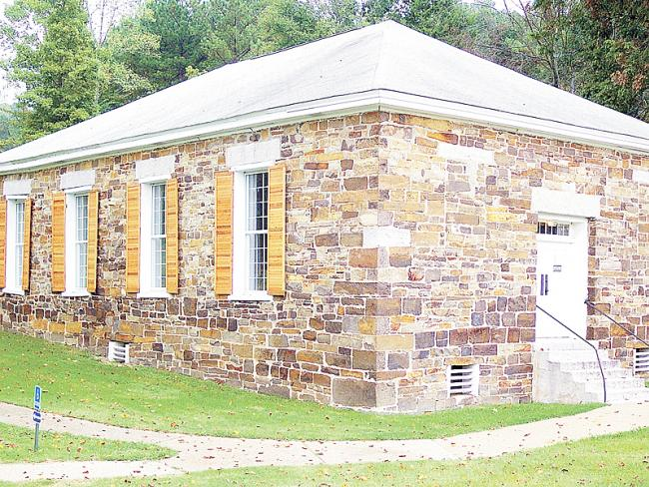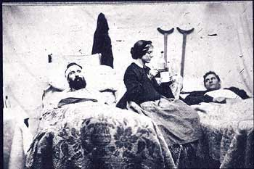

Late in 1861 Confederate Hospitals were organized in Cassville and by May of 1864 eight large Confederate hospitals were in operation. There were also several regimental hospitals in Cassville. More than 10,000 Confederates were treated in these hospitals. More than 500 Confederates died in them, of which about 300 are buried in the Confederate Cemetery. Also buried in the Cassville cemetery is Bartow's able Brigadier General W. T. Wofford.¹¹The only other known Confederate soldier buried in Cassville is W. M. Barrow of the 4th Regt. Louisiana Volunteers, who died in 1863 in a Confederate hospital at the age of twenty. The remainder of approximately 300 unknown soldiers sleep underneath marble slabs on a down sloping ridge on the northern side of the cemetery. They are aligned in jagged rows of 27 to 30 and rest underneath a grove of old cedar trees which cast a constant shadow on their graves.¹²
The Cassville battle did not reach major proportions of a major conflict. There were not that many killings in the little fighting that actually took place. The battle was fought Thursday, May 19, 1864 and was of more importance as to what would happen in the future than it was of that day. Hood's Advance and Retreat call the battle, "The Controversial Cassville Battle," or the "Question Mark" of the Atlanta Campaign.¹³ There were skirmishes in and around Cassville the day before and then there was further action which came a few days later.¹⁴
The Federals under William T. Sherman were headed South in early May. They had fought at Resaca, Calhoun, Lay's Ferry, and Adairsville in the days preceding.

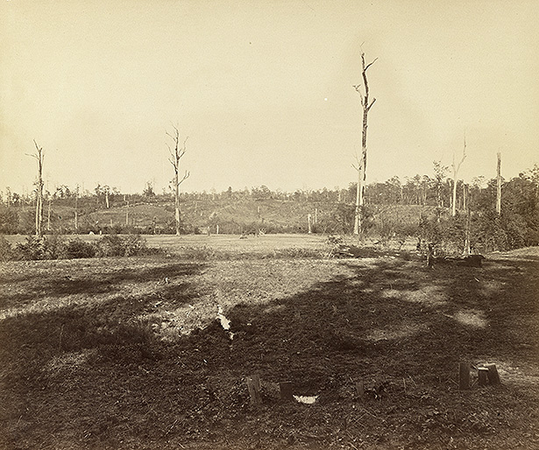 The Battlefield pf Resaca 1864 where southerns put up a figh near the Oostanaula River near Bowdoin homestead.

On May 18th Sherman waited in Adairsville with the Army of the Tennessee under McPherson on his right. However, McPherson had been stopped at Woolley's home just days before and only a fragment of his force remained in nearby Kingston. Sherman had the Army of the Cumberland and the Army of the Ohio with him at Adairsville. Strangely enough however, Sherman had no idea where the Johnston Army was at the time. He had allowed the Confederates to retreat out of his reach.¹⁵

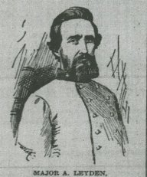

a Soldier Andrew Jackson Betterton Company A 9th battalion Georgia Artillery was assigned as a nurse to this hospital. This is some of the supplies he ordered. From Fold3

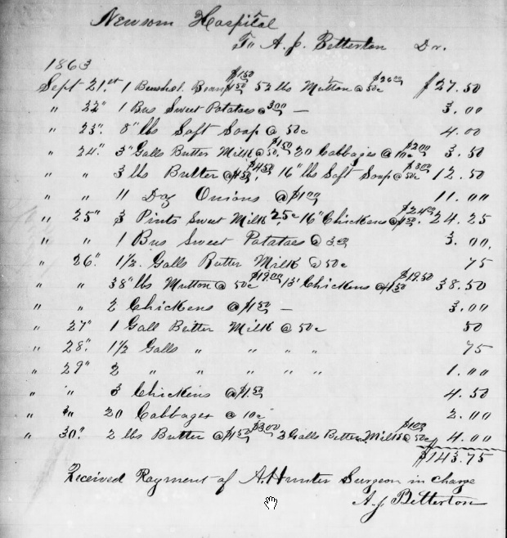
“While researching information for this site, I was surprized to discover that tiny Cassville, Bartow County, GA was the home of four hospitals during the Civil War! The hospitals listed for the period from the 12th of October, 1863, to March 16th, 1864 are: Newsom, Frank Ramsay, University and Flewellan Hospitals. Now, Cassville is a tiny place: just a few small public buildings and a small number of houses. It sure doesn't have a university and definitely no hospital. So I began thinking there must be some explanation for this Civil War era burst of growth with four hospitals! (As it turns out, Cassville was the Bartow county seat during the Civil War, but FOUR hospitals?)
This site, University of Texas lists the following hospitals and locations,
but there are no dates given for when they were in these locations:
Cassville, (Bartow Co.) Georgia, General Hospital, A. Hunter, surgeon
Barnsville, (Monroe Co.) Georgia: Flewellen Hospital, Miles H. Nash, surgeon
Opelika, Alabama: Flewellen Hospital, M. H. Nash, surgeon

Emory University contains information for the official correspondence of Samuel Hollingsworth Stout, the medical director of the Confederate Army hospitals in the southeastern states (1861-1865). In addition to this correspondence, the Civil War papers include general and special orders, circulars, and reports from subordinate medical officers relating to personnel, supplies, transportation of sick and wounded, and the transport of entire hospitals. Also included in this portion of the papers is an order book for Flewellen Hospital, Cassville, Georgia and a photograph of Stout in uniform.

So, what's a Flewellen Hospital doing in Alabama when there's already one in Cassville, Bartow Co.?
Here's a probable explanation: Sherpa Guides
Flewellen Hospital, named for Surgeon Edward A. Flewellen who was medical director of the Army of Tennessee . . . and is buried in Thomaston (Upson Co.), Georgia
"Barnesville (originally Monroe County, now Lamar County Seat) was an important railroad town on the Macon and Western Railroad. A western spur to Thomaston off the main line connected this factory town with the main line. Because of its location on a transportation line, it also was a Confederate hospital town with the following hospitals: Kingsville; Kingston, moved from Kingston [My husband Dan Bowdoin’s great grandfather was a pharmacist in this hospital & his ggf’s brother was a surgeon; Medical College Hospital, moved from Atlanta; Flewellen Hospital, named for Surgeon Edward A. Flewellen who was medical director of the Army of Tennessee and lived at The Rock and is buried in Thomaston; and Erwin Hospital.
One hundred and fifteen Confederate and two Union dead (84 unknown) reportedly from local hospitals and the Battle of Atlanta are buried in the Confederate section of Greenwood Cemetery. (Locals wrote that they could hear the boom of Sherman's cannons during the siege of Atlanta, 60 miles away.) One of the worst train wrecks of the Civil War occurred near Barnesville when a train carrying sick and wounded collided head-on with a supply train. Twenty-two were killed and many were wounded. The dead were buried in unmarked graves next to the tracks. A 15-foot marble shaft stands on a small mound in the center of the cemetery, erected in 1889, with the plain inscription 'To Our Confederate Dead.'
"On April 19, 1865, a skirmish occurred on the edge of Barnesville when a 2,000-man detachment of Union cavalry called Wilson's Raiders attacked a small local militia unit called the Dixie Rangers. The Rangers 'fought with gallantry, gradually withdrawing from the field,' according to local accounts. The Union cavalry burned some storehouses before moving on to Forsyth. Federal troopers came back through Barnesville on May 5, 1865 in pursuit of Jefferson Davis."
Okay, here's my guess. During the civil war, hospitals sprang up all over as needed: in taverns, stores, churches and other public buildings. The four hospitals mentioned for Cassville may have had their beginnings in other towns and counties. As the battle moved toward Atlanta and grew more heated, these hospitals may have moved to safer locations. Sherman had possibly already moved through Bartow County, so that area may have been considered a safe place to move the more southern hospitals as the war raged to Atlanta and points South. If this theory is correct, I still wonder where these four hospitals were located originally.

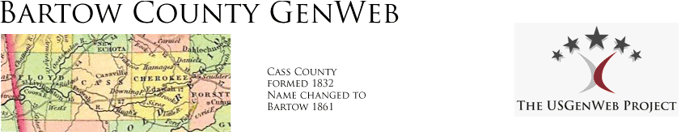
THE COUNTY SEAT OF BARTOW CO., GA
This is from the Bartow Co, GA GenWeb site: "Bartow County History"
"In 1833, the town of Cassville was laid out and made the county seat. By 1849, Cassville had a brick courthouse, three churches, seven stores, two hotels, and two colleges: The Cassville Female College and the Cherokee Baptist College.
"The views of General Cass on slavery caused a revulsion of feelings and the people of Cass County felt their county should be re-named after a Confederate hero. On December 8, 1861 the county changed the name from Cass to Bartow in honor of the gallant Francis S. Bartow, who perished at the head of his regiment in the opening battle of the Civil War, the Battle of Manassas. At the same time an effort was made to change the name of Cassville to Manassas without success.
"After the destruction of Cassville by the forces of General Sherman in 1864 the county seat was changed to Cartersville, then a small, thriving town on the Etowah River. Cartersville was named for Farish Carter, esq., perhaps the wealthiest land owner in the State during the ante-bellum period. The town was incorporated by an Act of Legislature approved February 5, 1850."

BARTOW COUNTY, GA - MILITARY Cassville Hospital CSA

*****************
Copyright. All rights reserved.
http://www.usgwarchives.net/copyright.htm

http://www.usgwarchives.net/ga/gafiles.htm
***********************
This file was contributed for use in the USGenWeb Archives by:
Terry Foenander tfoenander@hotmail.com

For more information see:
http://home.ozconnect.net/tfoen/cassville.htm

C.S. Army Deaths at Cassville, Georgia Hospitals.

List of Deaths of CS Army Personnel at Cassville, Georgia, Hospitals.

as listed in the Atlanta "Southern Confederacy."

transcribed, and compiled by Terry Foenander.

The following list of names, originally arranged by
state, but re-arranged alphabetically by this author,
was extracted from the Atlanta newspaper, the Southern
Confederacy, dated March 25, 1864, and was preceded by
the following notation:

"Below is appended a list of all deaths occurring among
the soldiers at this post in the Newsom, Frank Ramsay,
University and Flewellan Hospitals, from the 12th of
October, 1863, to March 16th, 1864. By giving this
list publicity some bereaved family may possibly
receive the first tidings that a loved member of the
home circle has gone to his last sleep, and to them is
given the consolation that nothing was left undone by
experienced and humane and attentive physicians to
arrest the destroyer."

Each name is followed by the soldiers unit, and then
the date of death. All the deaths shown occurred in
the five or six month period prior to the publication
of the list of names, and is not a complete listing of
all deaths at the Cassville hospitals throughout the
war. Additional data has been extracted from the
sources shown at the end of the list. The newspaper
listing did not specify cause of death, or which
particular hospital each soldier died at.
Unfortunately the Southern Confederacy did make some
errors in publication. The major error spotted by
this author was of a dozen names which were included
under the listings for Florida, but which should have
been listed under those soldiers from Georgia. I have
corrected these listings by including the actual state
in brackets. Undoubtedly there are other errors
included in the publication of the list in the
newspaper, and these will be corrected where possible.

William Ashby, company A, 41st Tennessee, October 28,
1863.

A.M. Barrow, company F, 4th Tennessee, December 6,
1863.

John W. Bell (captain), company A, 32nd Alabama,
February 14, 1864. [appointed from Clarke County,
Alabama - AL Rosters, 640.]

---- Benefield, company B, 39th Alabama, December 21,
1863.

John M. Benson, company A, 40th Georgia, January 21,
1864. [private, October 15, 1863; sick in hospital,
December 31, 1863 - GA Rosters, 4, 343.]

J.W. Black, company G, 36th Georgia, January 27, 1864.

W.W. Boatwright, company A, 10th South Carolina,
February 3, 1864.

William E. Bobo (corporal), company K, 41st Florida
[Georgia], March 12, 1864. [enlisted as second
corporal, March 4, 1862; captured at Vicksburg,
Mississippi, July 4, 1863; paroled July 6, 1863 - GA
Rosters, 4, 499.]

Aaron J. Boggs, company I, 28th Alabama, November 20,
1863.

---- Bordeaux, company G, 30th Louisiana, December 9,
1863.

Felix Brachin, company B, 27th Tennessee, November 27,
1863.

Abraham B. Bradley, company D, 60th North Carolina,
January 4, 1864. [private; born Greenville District,
South Carolina; resided in Henderson County, North
Carolina on enlistment at age 23, July 10, 1862;
deserted November 13, 1862; returned to duty in March-
April, 1863; deserted again on September 1, 1863;
reported sick in hospital, November-December, 1863 - NC
Rosters, 14, 532.]

L.H. Bragg, company A, Hawkin's Sharp Shooters, no
further information shown.

S.E. Bridges, company E, 63rd Virginia, October 2,
1863.

Calvin (or Clavin) Brown (sergeant), company F, 65th
Georgia, December 9, 1863. [originally enlisted in
Infantry Battalion, Smith's Legion, Georgia Volunteers,
June 17, 1862; appointed 4th sergeant; transferred to
company F, 65th Georgia Infantry, March, 1863; admitted
to Lumpkin Hospital, Rome, Georgia, October 13, 1863,
but died in a Cassville hospital - GA Rosters, 6, 638.]

S.G. Brown, company B, 60th North Carolina, January 27,
1864. [private; enlisted in Madison County, North
Carolina, April 5, 1862; reported sick in hospital,
November-December, 1862; returned to duty in January-
February, 1863 - NC Rosters, 14, 516.]

Robert Bruce, company F, 2nd South Carolina, October
21, 1863.

Raymond Buckhalter, company B, 19th South Carolina,
January 25, 1864.

Samuel J. Burrel, company A, 42nd Georgia, January 25,
1864. [enlisted November 4, 1862, as private;
captured at Vicksburg, Mississippi, July 4, 1863;
paroled July 7, 1863 - GA Rosters, 4, 513.]

J.E. Butler, Alexander's Battery, no further
information shown.

J.W. Carr, company G, 55th Georgia, December 9, 1863.

John P. Carr, company C, 26th Florida [Georgia], March
13, 1864.

John Carrie, company F, 24th South Carolina, December
18, 1863.

Travers M. Chandler, company I, 66th Georgia, January
20, 1864. [enlisted as private, September 1, 1863 -
GA Rosters, 6, 756.]

James Clack, company D, 60th North Carolina, November
17, 1863. [private; shown as James A. Clark; enlisted
at Tullahoma, Tennessee, January 20, 1863, as
substitute for private Branson Broils of the same
company - NC Rosters, 14, 533.]

Daniel Clowers, company I, 54th Virginia, October 5th
[?], 1863.

Jacob Clowers, company I, 54th Virginia, November 15,
1863.

J.W.C. Cole, company B, 56th Georgia, January 19, 1864.

Berry Collins, company H, 24th Georgia, November 17,
1863. [roster shows the surname as Collier or Colyer;
private - GA Rosters, 3, 65.]

James H. Congue, Dent's Battery, no further information
shown.

J.W. Crash, company G, 47th Georgia, December 12, 1863.

Freeman Crump, company D, 7th Florida Cavalry, January
26, 1864.

Jasper Curl, company H, 1st Florida Cavalry, February
10, 1864.

Joseph Davis, company B, 8th Tennessee Cavalry,
November 6, 1863.

S.J. Dickson (sergeant), company A, 26th Battalion
Georgia, December 12, 1863.

D.W. Dodson, company F, 54th Virginia, December 16,
1863.

J.W. Dubose, company D, 16th Alabama, December 8, 1863.

W.Frank Dunaway, company G, 4th Georgia, January 25,
1864. [actually served in company G, 46th Georgia
Infantry; enlisted as private, March 4, 1862; roster
entry shows he died at Marietta, Georgia, hospital - GA
Rosters, 4, 990.]

T.J. Eddingfield, company A, 26th Battalion Georgia,
January 28, 1864.

John W. Edson, company H, 46th Florida [Georgia],
February 8, 1864. [surname shown as Eidson; private,
May 1, 1862 - GA Rosters, 4, 1000.]

J. Edwards, company C, 37th Tennessee, December 31,
1863.

William Elison, company H, 42nd Georgia, January 24,
1864. [was actually a private in company D, died at
Newsome Hospital - see GA Roster, 4, 543.]

Henderson D. Estes, company E, 58th North Carolina,
February 3, 1864. [private; born Caldwell County,
North Carolina; occupation, farmer; enlisted at age 24,
July 5, 1862; mustered in as musician (drummer), later
appointed drum major; transferred to field and staff,
prior to May 1, 1863; reduced to ranks and transferred
back to his old company, June 20, 1863 - NC Rosters,
14, 330.]

James C. Floral (corporal), company C, 63rd Tennessee,
November 18, 1863.

Thomas Fort, company G, 46th Georgia, January 19, 1864.
[first name shown as Tomlinson; enlisted as private in
company K, 2nd Georgia Infantry, July 17, 1861;
discharged for disability, September 12, 1861;
appointed 4th corporal, company G, 46th Georgia
Infantry, March 4, 1862; musician, August, 1862 - GA
Rosters, 4, 988.]

J.W. Gabel, 9th Battalion Sharp Shooters, Federals, no
further information shown.

Samuel Garrett, company H, 30th Alabama, January 17,
1864.

J.T. Garrison, company C, 9th Texas, October 17, 1863.

Roof Gordon, company A, 54th Virginia, October 28,
1863.

John Graves, company K, 58th Alabama, January 20, 1864.

John Gray, company E, 33rd Alabama, March 2, 1864.

John Green, company G, 47th Florida [Georgia], March
12, 1864. [enlisted as private, September 1, 1862;
died of pneumonia in Newsome Hospital, Cassville,
Georgia - GA Rosters, 5, 72.]

Harvey H. Gregg, company E, 58th North Carolina,
January 20, 1864. [private, actually served in
company D; surname shown as Gragg; enlisted at Watauga
County, North Carolina, December 27, 1863; reported
sick in hospital, January 15, 1864; had previously
served as captain in the 98th Regiment, North Carolina
Militia - NC Rosters, 14, 315.]

J.W. Haley, company H, 11th Florida, February 14, 1864.

J.T. Hamilton, company K, 30th Alabama, January 20,
1864.

S. Hamilton, company I, 3rd Florida, February 15, 1864.

L.H. Hampton, company A, 12th Tennessee, October 28,
1863.

Richard J. Hardy (sergeant), company G, 43rd Georgia,
December 16, 1863. [roster actually indicates his
rank as private, at death; enlisted March 10, 1862 - GA
Rosters, 4, 688.]

Ben A. Harrison, company H, 66th Georgia, January 24,
1864. [enlisted as private, September 15, 1863 - GA
Rosters, 6, 749.]

John Hawley, company A, 8th Mississippi, January 27,
1864.

H.J. Hays, company E, 60th North Carolina, November 19,
1863. [probably Hugh Hays who had enlisted in this
company, at Camp Martin, Mitchell County, North
Carolina, on June 27, 1862 - NC Rosters, 14, 333.]

S.W. Henderson, company B, 36th Alabama, October 28,
1863.

Manuel B. Hernandes (corporal), company A, 1st Florida,
December 12, 1863. [enlisted May 31, 1861, at
Pensacola, Florida - FL Rosters, 1, 78.]

Lawson T. Herrin, company K, 65th Georgia, January 27,
1864. [enlisted as private, September 11, 1863 - GA
Rosters, 683.]

Lewis Hilton, company D, 54th Virginia, November 18,
1863.

James Hobbs, company D, 66th Florida [Georgia],
February 3, 1864.

E. Holland (sergeant), company F, 27th Tennessee,
October 19, 1863.

John Thomas Houghton, company G, 25th Georgia, December
15, 1863. [was actually a member of company G, 46th
Georgia Infantry; enlisted as private, March 4, 1862 -
GA Rosters, 4, 991.]

J.A. Houston, company K, 36th Alabama, January 30,
1864.

Edmond Howard, company A, 10th South Carolina, January
29, 1864.

James M. Hughes, company I, 65th Georgia, December 16,
1863. [originally enlisted as private in Infantry
Battalion, Smith's Legion, Georgia Volunteers, February
15, 1863; transferred to company I, 65th Regiment
Georgia Infantry, March, 1863; in Loudon, Tennessee,
hospital, March 19 - June 30, 1863; Dalton, Georgia,
hospital, October 14-31, 1863; died in hospital at
Cassville - GA Rosters, 6, 674.]

John C. Hughes, company G, 1st Tennessee Cavalry,
January 31, 1864.

Joseph Hutch, company C, 10th South Carolina, February
1, 1864.

William Jarniken, company D, 1st Florida, November 3,
1863.

A. Johnson, company F, 38th Alabama, January 25, 1864.

W. Johnson, Dent's Battery, no further information
shown.

Wiley Jones, company D, 66th Florida [Georgia],
February 10, 1864. [enlisted as private, July 28,
1863; died of brain fever in Newsom Hospital, Cassville
(roster shows date of death as January 10, 1864) - GA
Rosters, 6, 720.]

John Kemp, company L, 58th North Carolina, January 26,
1864. [private; enlisted in Ashe County, North
Carolina, September 10, 1863 - NC Rosters, 14, 412.]

James D. Kerby, company E, 16th South Carolina,
February 3, 1864.

C.H. Knight, company B, 32nd Mississippi, October 22,
1863.

G. Lee, company K, 7th Mississippi, December 9, 1863.

William H. Levert, company F, 24th South Carolina,
January 23, 1864.

Thaddeus C. Lloyd, company K, 32nd and 58th Alabama,
March 5, 1864.

W.A. Maddox, company B, 5th Kentucky, November 7, 1863.

Thomas Marion, company G, 38th Alabama, December 12,
1863.

J.H. Marsh, company G, 25th Georgia, December 15, 1863.

---- Matthews, company E, 10th Texas Cavalry, October
20, 1863.

Dan McKracken, company I, 32nd and 58th Alabama,
January 27, 1864.

Isaac Moody, company F, 47th Florida [Georgia], March
18, 1864.

T.H. Morgan, company I, 36th Florida [Georgia], March
5, 1864.

W.P. Morgan, company G, 40th Florida [Georgia], March
15, 1864. [enlisted as private, December 24, 1863;
died of pneumonia - GA Rosters, 4, 400.]

J.D.C. Nixon, company H, 24th Mississippi, December 13,
1863.

Sanford V. Owen, company I, 66th Florida [Georgia],
February 1, 1864. [enlisted as private, September 1,
1863; died in Newsom Hospital, Cassville - GA Rosters,
6, 759.]

John D. Owens, company F, 30th Alabama, March 15th,
1864.

Joshua Padgett, company E, 24th South Carolina,
February 16, 1864.

Solomon Pippin, company H, 4th Florida, October 13,
1863. [born 1842; enlisted September 7, 1861, at
Vernon, Florida; died at the University Hospital,
Cassville, Georgia - FL Rosters, 1, 438.]

Charles W. Plunckett, company F, 42nd Georgia, January
17, 1864. [roster shows his surname as Plunkett;
enlisted as private, September 5, 1863; roll dated
December 9, 1863, shows him as actually being in an
Atlanta, Georgia, hospital - GA Rosters, 4, 567.]

Josiah F. Polk, company F, 1st Florida Cavalry,
December 12, 1863.

James M. Pope, company K, 22nd Alabama, January 30,
1864.

Wesley Pope, company C, 51st Georgia, December 8, 1863.
[born 1837; enlisted as private, March 4, 1862 - GA
Rosters, 5, 391.]

Robert J. Pounds, company G, 4th Florida Infantry,
February 12, 1864. [born 1838; enlisted July 2, 1861,
at Ocala, Florida - FL Rosters, 1, 429.]

Thomas Proctor, company E, 43rd Georgia, January 25,
1864. [enlisted as private, March 10, 1862 - GA
Rosters, 4, 669.]

J. Qustes, company E, 54th Virginia, November 24, 1863.

Jeptha Ramsey, Alexander's Battery, no further
information shown.

Samuel Ratcliff, company E, 6th Texas, November 17,
1863.

W.B. Rayburn, company H, 38th Alabama, December 9,
1863.

William Reeves (sergeant), company K, 23rd Alabama,
January 27, 1864.

J. Richards, Smith's Battery, no further information
shown.

H. Robbins, company I, 8th Arkansas, November 18, 1863.

A.M. Russell, company A, 28th Alabama, December 12,
1863.

Reuben Savage, company D, 18th Georgia, November 20,
1863. [enlisted as private, March, 1863 - GA Rosters,
2, 650.]

R.F. Sawyer, company H, 30th Alabama February 28, 1864.

B.F. Scott, company H, 4th Kentucky, January 24, 1864.

W.B. Scott, company F, 27th Tennessee, October 21,
1863.

J.N. Sellers (sergeant), company F, 47th Georgia,
October 16, 1863.

A.L. Smith, company C, 60th North Carolina, October 16,
1863. [sergeant; name actually shown in roster as
D.L. Smith; enlisted in Buncombe County, North
Carolina, July 8, 1862, as private; promoted sergeant,
March 23, 1863; wounded in head at Chickamauga,
Georgia, September 20, 1863; nominated for Badge of
Distinction for gallantry at Chickamauga - NC Rosters,
14, 530.]

J.T. Smith, company B, 2nd Battalion Georgia, October
15, 1863.

W.G. Smith, company A, 26th Battalion Georgia, December
9, 1863.

Charles Snow, company D, 65th Florida [Georgia],
February 5, 1864. [originally enlisted as private in
company F, Infantry Battalion, Smith's Legion, Georgia
Volunteers, February 4, 1863; transferred to company D,
65th Georgia Infantry, March, 1863; absent without
leave, July 28, 1863; rejoined company, December 23,
1863, and placed under arrest - GA Rosters, 6, 625.]

R.D. Spivey (corporal), company L, 154th Tennessee,
October 12, 1863.

W.J. Suddith, company G, 60th Alabama, January 19,
1864.

Wardedell Taylor, company E, 58th North Carolina,
January 5, 1864. [private; name actually shown in
roster as Weistell Taylor; enlisted in Burke County,
North Carolina, August 29, 1862; reported sick in
hospital in September-October, 1863 - NC Rosters, 14,
341.]

James Thornhill, company C, 23rd Alabama, February 5,
1864.

D.W. Toland, company B, 24th Battalion Tennessee, March
13, 1864.

James Townsend, company B, 4th Florida, January 26,
1864.

John Turner, company F, 58th North Carolina, November
22, 1863. [corporal; born in McDowell County, North
Carolina, where he enlisted July 14, 1862, aged 18, as
private; promoted corporal prior to March 1, 1863 - NC
Rosters, 14, 356.]

James B. Tutt, company K, 7th Texas, March 16, 1864.

J.P. Vandever, company G, 28th Alabama, March 6, 1864.

J.E. Vaughan, company K, 28th Alabama, November 17,
1863.

Samuel B. Walker, company B, 2nd Kentucky, October 14,
1863.

J.W. Webb, company F, 24th South Carolina, March 4,
1864.

---- Williams, company I, 6th South Carolina, December
-, 1863.

S.P. Williams (sergeant), company C, 47th Georgia,
December 12, 1863.

J.F. Wilson, company E, 45th Mississippi, January 8,
1864.

J.W. Wisher, company H, 24th South Carolina, February
24, 1864.

S.H. Wood, company F, 4th Battery Alabama, October 21,
1863.

Additional Sources of Information:

AL Rosters: "Brief Historical Sketches of Military
Organizations Raised in Alabama During the Civil War,
[this single volumed publication is in fact a reprint
of pages 589 to 705 of the 1872 publication, by Willis
Brewer, titled Alabama: Her History, Resources, War
Record, and Public Men and includes just a listing of
the officers of all the units from that state who
served in the Civil War] Alabama State Department of
Archives and History, 1966.

FL Rosters: " Biographical Rosters of Florida's
Confederate and Union Soldiers, 1861-1865," 6 volumes;
compiled by David W. Hartman and David Coles; Broadfoot
Publishing Company, Wilmington, North Carolina, 1995.
Reference shows volume and page numbers.

GA Rosters: "Roster of the Confederate Soldiers of
Georgia, 1861-1865," 5 volumes; compiled by Lillian
Henderson, Director, Confederate Pension and Record
Department, Georgia, 1960. Reference shows volume and
page numbers.

NC Rosters: "North Carolina Troops, 1861-1865," 14
volumes (in 2001); compiled under the authority of the
North Carolina Division of Archives and History, 1961-
current. Reference shows volume and page numbers.

©Terry Foenander

June, 2001

